- What year did Galileo first use a telescope to look at the moon?

- What is a natural satellite?

- How far is the moon from Earth?

- How long doe it take for the moon to orbit around Earth?

- How long does it take to rotate on it’s own axis?

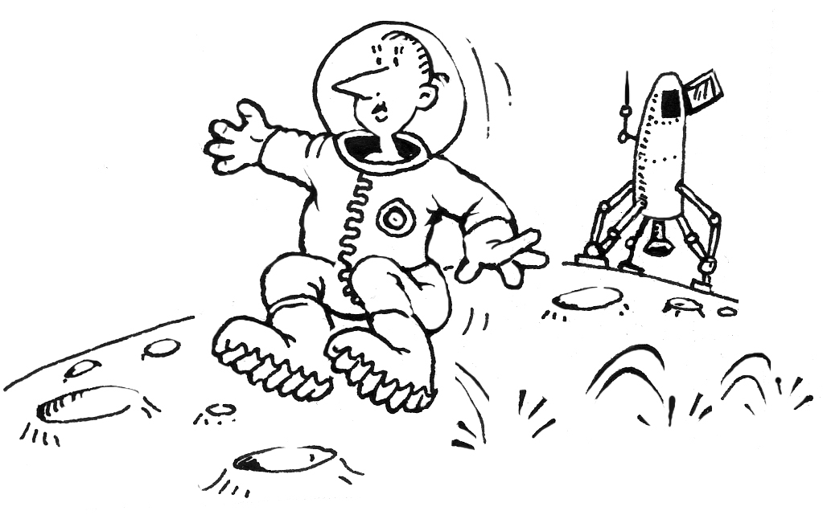
- Why does the same side of the moon always face the Earth?

- Why can we still see the tracks from the Lunar Rover on the moon?

- What causes all the ‘craters’ on the moon? Why doesn’t this happen on Earth ?

10. How does gravity compare on the moon to gravity on Earth?

